
CSA15 – CLOUD COMPUTING AND BIG DATA ANALYTICS

ASSIGNMENT 1 – CO1
Design, Analyse and Validate a Cloud-Based Solution for Migrating a
Legacy University Management System
CO1: Apply cloud computing technologies including hardware–software evolution, virtualization, web services, and service models to develop cloud-based solutions.

Field | Details | Field | Details
Student Name | L.Asif ali khan | Register Number | 192521009
Department / Section | B.TECH(IT) | Academic Year / Semester | 2025-2029
Faculty Name | Dr.R.LATHA | Nature of Assignment | Individual
Duration | 1 Week | Total Marks | 50
Submission Date | 31/10/2026 | Evaluation Date

MARK SHEET (Rubric-based evaluation)
Task | Title | Max | Awarded | Evidence / evaluation focus
1 | Introduce Cloud Computing | 3 |  | Definition; characteristics; deployment models; scenario mapping
2 | Trace Evolution and Hardware Evolution | 3 |  | Timeline; hardware evolution; relevance to university
3 | Analyse Internet Software Evolution | 3 |  | Web/software evolution; SOA; APIs; scenario relevance
4 | Apply Server Virtualization | 5 |  | Hypervisor types; VM/container comparison; consolidation; limitations
5 | Apply Web Services | 4 |  | SOA and SOAP/REST; three university APIs; request/response examples
6 | Analyse IaaS, PaaS and SaaS | 5 |  | Responsibility layers; five-application mapping; comparison; providers
7 | Examine XaaS | 3 |  | Four or more variants; two justified choices; provider risks
8 | Design Cloud Solution Architecture | 5 |  | Labelled diagram; deployment/service models; scaling; security; DR
9 | Hands-on Implementation and Documentation | 4 |  | Running VM/container; PaaS/SaaS; tests; actual screenshots
10 | Evaluate and Recommend  Final Solution | 7 |  | Three-way comparison; 3-year costs; risks; phased roadmap
11 | Day-4 Design Challenge | 8 |  | Impact; evaluation; adaptation; evidence-based defence
 | TOTAL | 50 |  | Percentage :

EVIDENCE VERIFICATION CHECKLIST

Tasks | Evidence expected | Status (✓  / P / ✗) | Evaluator note
1–3 | Conceptual explanations,  comparisons and relevant  illustrations | ✓ | Explanations and relevant scenario mapping documented
4 | Virtualization calculations with stated assumptions and peak-load caution | ✓ | Calculations present; practical capacity validation recommended
5–7 | API examples, service responsibility table and justified XaaS choices | ✓ | Required conceptual evidence documented
8 | Labelled architecture diagram,  caption below figure and component justification | ✓ | Architecture documented; sizing assumptions need testing
9 | Actual code, environment details, execution logs, API outputs and screenshots | P | Procedures provided; actual execution evidence not established
10 | Cost assumptions, 3-year totals, risk controls and migration roadmap | ✓ | Estimates and rationale documented
11 | Day-4 changes, 10× load strategy,  99.9% target and 40-college isolation | ✓ | Design analysis documented; practical validation pending

IMPLEMENTATION EVIDENCE CHAIN

Evidence item | Status | Observation
Source code | ✓ | Flask REST API and Dockerfile provided in the proposed implementation
Virtualization | P | Docker container configuration documented; running-container evidence required
PaaS or SaaS | P | Managed web-service deployment procedure described; live deployment not verified
Functional test | P | Expected HTTP 200 response and JSON output documented; actual output required
Failure case | P | HTTP 404 test case documented; actual execution record required
Screenshots | P | Screenshot requirements identified; authentic screenshots need verification
Reproducibility | ✓ | Build commands, run commands, endpoints and expected results specified

OVERALL REMARKS

L.ASIF ALI KHAN  Student Signature | _______________  Faculty Signature | _______________  Program Director

MANDATORY SUBMISSION EVIDENCE CHECK

✓ = Present in documented answer; P = Partly present; ✗ = Missing / not satisfied
Task | Evidence expected | Status | Evaluator note
1 | Cloud definition, characteristics, deployment models and scenario mapping | ✓ | All conceptual requirements covered
2 | Evolution timeline, hardware development and university relevance | ✓ | Well explained with relevant examples
3 | Internet software evolution, SOA and APIs | ✓ | Clear explanation and scenario relevance
4 | Hypervisors, VM/container comparison and consolidation calculations | ✓ | Calculations included; peak-load limitations discussed
5 | SOAP/REST comparison and three university APIs | ✓ | API methods and request/response examples documented
6 | IaaS/PaaS/SaaS responsibility layers and application mapping | ✓ | All five applications categorized with justification
7 | XaaS variants and two justified selections | ✓ | Six variants explained; DBaaS and DRaaS recommended
8 | Labelled architecture, scaling, security and disaster recovery | ✓ | Design and component justifications documented
9 | Working container, PaaS/SaaS deployment, actual tests and screenshots | P | Code and procedures provided; actual execution evidence requires verification
10 | Three-year cost comparison, risks and migration roadmap | ✓ | Cost assumptions, calculations and recommendations included
11 | Impact analysis, 10× load, 99.9% availability and tenant isolation | ✓ | Changed requirements evaluated; load-test evidence recommended

IMPLEMENTATION EVIDENCE CHAIN
Evidence item | Status | Observation
Source code | ✓ | Python Flask REST API and Dockerfile documented
Virtualization | P | Docker build and run procedures provided; execution screenshot required
PaaS or SaaS | P | Cloud deployment steps described; actual deployment confirmation required
Functional test | P | HTTP 200 and expected JSON response documented; actual test output required
Failure case | P | HTTP 404 test case included; execution evidence required
Screenshots | P | Required screenshots identified but authenticity and completeness not verified
Reproducibility | ✓ | Installation, configuration, commands and testing steps documented
Interpretation | ✓ | Technical outcomes and implementation limitations explained
Code and report consistency | ✓ | Proposed API, Docker configuration and testing procedure are aligned

SUBMISSION CHECKLIST (Not Separately Marked)
Requirement | Status
All 11 tasks answered | ☒ Yes ☐ Partly ☐ No
Cloud concepts and comparisons explained | ☒ Yes ☐ Partly ☐ No
Virtualization calculations included | ☒ Yes ☐ Partly ☐ No
API examples and service models explained | ☒ Yes ☐ Partly ☐ No
Cloud architecture diagram included | ☒ Yes ☐ Partly ☐ No
Implementation and testing evidence provided | ☐ Yes ☒ Partly ☐ No
Three-year cost analysis and roadmap included | ☒ Yes ☐ Partly ☐ No
Day-4 design challenge completed | ☒ Yes ☐ Partly ☐ No
Figures and screenshots included | ☐ Yes ☒ Partly ☐ No
Table and figure numbering correct | ☐ Yes ☒ Partly ☐ No
Viva recommended | ☒ Yes ☐ No

CSA15 – Cloud Computing and Big Data Analytics

ASSIGNMENT 1
CO1: Apply cloud computing technologies including hardware–software evolution, virtualization, web services, and service models to develop cloud-based solutions.

Assignment Title: Design, Analyse and Validate a Cloud-Based Solution for Migrating a Legacy University Management System (Total Marks – 50)
Duration: 1 week

Scenario – Smart Campus Cloud Migration
A multi-campus university currently runs its Student Information System, Learning Management System, Library System, Exam Portal and Email on ageing physical servers in a single on-premise data centre. Each application has its own dedicated server, which stays idle for most of the year but fails to cope during admissions, result publication and online-exam weeks.
The university's current environment is:
- 12 physical servers, average CPU utilisation of about 15%, with peaks above 95% during admissions and exams
- Approximately 25,000 students and 2,000 staff across 4 campuses
- Applications built as large monolithic programs, with no public interfaces for mobile apps or partner colleges
- High capital expenditure, slow procurement (6–8 weeks per server) and no disaster recovery site
As a cloud consultant, you must study how computing evolved to the cloud model, and then design a cloud-based solution that uses virtualization, web services and an appropriate mix of service models (IaaS, PaaS, SaaS and XaaS) for the university. All recommendations must be justified in terms of cost, scalability, availability and manageability.
Design Challenge:
On Day 4, the university announces that it will launch a mobile app and open student-record and fee-payment services to 40 affiliated colleges. Expected load is 10 times the current peak, with a requirement of 99.9% availability and a limited operating budget. Re-evaluate your original design and decide whether it should be retained, modified or redesigned.

TASK 1 – Introduce Cloud Computing and Map It to the Scenario (3 Marks)
Design and Propose cloud computing model for the context of the university's problems.
- Definition of cloud computing and the five essential characteristics (on-demand self-service, broad network access, resource pooling, rapid elasticity, measured service)
- Deployment models (public, private, hybrid, community) and which one suits the university
- Three problems of the current on-premise setup and how each cloud characteristic addresses them
- Benefits and limitations of cloud adoption for the university

Evidence Expected
A clear explanation of cloud characteristics and deployment models, mapped to the university's actual problems.

TASK 2 – Trace the Evolution and Hardware Evolution (3 Marks)
Trace how computing infrastructure evolved to make cloud computing possible.
- A timeline from mainframes, minicomputers and PCs, to client–server, clusters, grid computing, utility computing and cloud
- Hardware evolution: multi-core processors, commodity servers, high-capacity storage, high-speed networking and data centres
- How each stage solved a limitation of the previous one
- Which stage the university's current system corresponds to, with reasons

Evidence Expected
A labelled timeline or diagram, with a justified explanation of how hardware advances enabled the cloud.

TASK 3 – Analyse Internet Software Evolution (3 Marks)
Explain how internet software evolved and why it supports cloud services.
- Evolution from static web pages to dynamic web, Web 2.0, SOA, mashups and cloud-hosted applications
- Role of browsers, HTTP, AJAX and APIs in delivering software over the internet
- Comparison between desktop software, client–server software and web-delivered software
- How this evolution affects the design of the university's applications

Evidence Expected
A comparative explanation of software evolution stages, linked to the university's application design.

TASK 4 – Apply Server Virtualization (5 Marks)
Apply server virtualization to consolidate the university's 12 physical servers.
- Explain how a hypervisor works, and distinguish Type-1 and Type-2 hypervisors, with examples
- Compare full virtualization, para-virtualization, OS-level virtualization (containers) and hardware-assisted virtualization
- Propose which applications should run as virtual machines and which as containers, with reasons
- Calculate the consolidation: with an average utilisation of 15% per server and a target host utilisation of 70%, estimate how many physical hosts are needed (show your assumptions and working)
- Discuss live migration, snapshots and resource over-commitment as benefits, and the risks of virtualization (noisy neighbour, hypervisor failure, security isolation)
Show your calculation. A final number without working will not receive full credit.

Evidence Expected
A justified virtualization plan with a worked consolidation calculation and discussion of benefits and risks.

TASK 5 – Apply Web Services (4 Marks)
Analyse web services to expose the university's functions to other systems.
- Overview of web services and their role in cloud and SOA
- Compare SOAP, WSDL, UDDI and RESTful services (HTTP methods, JSON/XML)
- Identify at least three university functions to expose as web services (for example, result lookup, fee payment, library search) and define the endpoint, method and sample request/response for each
- Justify whether SOAP or REST is more suitable for each function

Evidence Expected
A defined set of web services with sample request/response formats and a justified choice of SOAP or REST

TASK 6 – Analyse the Service Models: IaaS, PaaS and SaaS (5 Marks) Analyse which service model fits each university application.
- Define IaaS, PaaS and SaaS, and show who manages which layer (hardware to application) in each model
- Categorise the five university applications (SIS, LMS, Library, Exam Portal, Email) into IaaS, PaaS or SaaS, with reasons
- Compare the models on control, cost, scalability, maintenance effort and vendor lock-in
- Give one real provider example for each model
Present your categorisation in a table, but explain the reasoning behind each decision. A table alone is not sufficient.

Evidence Expected
A reasoned mapping of applications to service models, supported by a layer-wise responsibility comparison.

TASK 7 – Examine XaaS (3 Marks)
Examine the broader XaaS (Anything-as-a-Service) concept for the university.
- Explain XaaS and describe at least four variants (for example DaaS,
BaaS/MBaaS, FaaS, DBaaS, Security-as-a-Service, Disaster-Recovery-as-a-Service)
- Select two XaaS offerings that would benefit the university, and justify them
- Discuss the risks of over-reliance on multiple 'as-a-Service' providers

Evidence Expected
An analysis of XaaS variants, with justified selection of two offerings for the university.

TASK 8 – Design the Cloud Solution Architecture (5 Marks)
Bloom's Level: Level 6 – Create | Action verbs: Design, Construct, Propose
Create a complete cloud architecture for the university by combining virtualization, web services and service models.
- An architecture diagram showing users, load balancer, web/application tier, database tier, storage, API layer and DR region
- The deployment model and the service model chosen for each component
- How elasticity (auto-scaling) will handle admissions and exam peaks
- Basic security and availability measures (access control, encryption, backup, multi-zone deployment)

Evidence Expected
A labelled architecture diagram with written justification for each component and design decision.

TASK 9 – Hands-on Implementation and Documentation (4 Marks)
Implement a small proof-of-concept of your design using a free-tier cloud account or a local virtualization tool.
- Create a virtual machine or container (using AWS/Azure/GCP free tier, VirtualBox, or Docker) and host a simple web page or REST API for one university function
- Deploy a SaaS or PaaS component (for example a cloud-hosted database, a serverless function or a static site)
- Test the web service with a client (browser, Postman or curl) and record the output
- Provide screenshots, configuration steps and any issues faced

Evidence Expected
Annotated screenshots and clear, reproducible steps showing that the proof-of-concept works.

TASK 10 – Evaluate and Recommend the Final Solution (7 Marks)
Evaluate your design and recommend the final cloud solution for the university.
- Compare on-premise, IaaS-based and PaaS/SaaS-based options on cost
(CapEx vs OpEx), scalability, availability, security and effort
- Estimate a simple 3-year cost comparison using stated assumptions
- Identify the main risks (vendor lock-in, data privacy, downtime, skills gap) and give mitigation steps
- Provide your final recommendation and a short migration roadmap (which application moves first, and why)
Your recommendation must be supported by the analysis in the previous tasks. Choosing a popular cloud provider without justification is not sufficient.

Evidence Expected
A technically justified recommendation, supported by a cost comparison, risk analysis and migration roadmap.

DAY-4 DESIGN CHALLENGE

TASK 11 – Re-evaluate and Adapt the Design (8 Marks)

Changed Requirement
The university will now launch a mobile app and open student-record and fee-payment services to 40 affiliated colleges. Expected load is 10 times the current peak, availability must be 99.9%, and the operating budget is limited.
Re-evaluate your original design in response to these changed conditions. You may:
RETAIN → MODIFY → or REDESIGN
your original solution.
Impact Analysis – 2 Marks Discuss:
- What has changed from the original problem
- Which original assumptions (load, users, availability, cost) are affected
- Why the web services and APIs now become critical
- How multi-tenant access by 40 colleges affects security and isolation
Evidence Expected: A clear analysis of how the changed requirements affect the original cloud design.
Evaluation of the Original Design – 2 Marks Discuss:
- Whether the chosen service models and virtualization plan can handle a 10x load
- Whether auto-scaling and the single-region deployment are sufficient for
99.9% availability (about 8.76 hours of downtime allowed per year)
- Whether cost remains acceptable under the new load
- Whether another service model or XaaS offering would give better overall results
Evidence Expected: A technically supported evaluation of the original design under the new conditions.
Adaptation or Redesign – 2 Marks Discuss:
- Decide whether to retain, modify or redesign the solution
- Describe the revised architecture (for example API gateway, container orchestration, serverless components, multi-zone deployment or a hybrid model)
- Explain what changed in the service model mix and in the virtualization approach
- If you retain the original design, give sufficient technical justification for why no change is required
Evidence Expected: An appropriate design response to the changed requirement, with clear technical reasoning.
Evidence-Based Defence – 2 Marks Discuss:
- Capacity and availability calculations
- Cost comparison between the original and the revised design
- Security and multi-tenancy considerations
- Trade-offs such as vendor lock-in, complexity and migration effort
Evidence Expected: A well-supported final decision that follows logically from the analysis.
1 – Introduce Cloud Computing and Map It to the Scenario
Answer
Introduction to Cloud Computing
Cloud computing is a technology that provides computing resources such as servers, storage, databases, networking, and software over the Internet. It allows users to access resources whenever required without maintaining expensive physical infrastructure.
For a university, cloud computing can be used to manage student records, examination systems, online learning platforms, faculty information, and administrative activities efficiently.
Five Essential Characteristics of Cloud Computing
Characteristic | Explanation | Application in University
On-demand self-service | Users can access computing resources whenever needed without human interaction with the service provider. | Faculty and students can access learning platforms and storage on demand.
Broad network access | Cloud services are accessible through the Internet using computers, laptops, tablets, and smartphones. | Students can access study materials and results from anywhere.
Resource pooling | Computing resources are shared among multiple users based on demand. | University departments can share cloud storage and computing resources.
Rapid elasticity | Resources can be increased or decreased according to workload. | The examination system can handle more users during result publication.
Measured service | Resource usage is monitored and charged based on consumption. | The university pays only for the cloud resources it uses.

Cloud Deployment Models
There are four main deployment models:
- Public Cloud: Services are provided over the Internet by providers such as AWS, Microsoft Azure, and Google Cloud.
- Private Cloud: Cloud infrastructure is dedicated to a single organization, providing greater control and security.
- Hybrid Cloud: Combines public and private cloud infrastructure to provide flexibility and security.
- Community Cloud: Infrastructure is shared by organizations with similar requirements, such as multiple universities.
Proposed Model: Hybrid Cloud
A hybrid cloud is the most suitable model for the university because it provides both security and flexibility.
- Private cloud can store sensitive student records, examination data, and financial information.
- Public cloud can host online learning platforms, websites, and other applications requiring high scalability.
- It provides better resource utilization, security, and cost efficiency.
Problems in the Current On-Premise Setup and Cloud Solutions
Current Problem | Cloud Characteristic | Proposed Solution
Limited server capacity during admissions and examinations. | Rapid elasticity | Cloud resources can be increased during peak periods and reduced afterward.
Students and faculty cannot access systems easily from different locations. | Broad network access | Cloud applications can be accessed through the Internet from any location.
High cost of purchasing and maintaining physical servers. | Resource pooling and measured service | Shared resources reduce infrastructure costs, and the university pays according to usage.
Benefits of Cloud Adoption
- Reduces the cost of purchasing and maintaining physical servers.
- Improves accessibility for students and faculty.
- Provides scalability during admissions, examinations, and result publication.
- Improves data backup and disaster recovery.
- Supports efficient resource utilization and centralized management.
Limitations of Cloud Adoption
- Requires a reliable Internet connection.
- Sensitive university data may face security and privacy risks.
- Cloud service costs may increase with excessive usage.
- The university may become dependent on a particular cloud provider.

Conclusion
Cloud computing provides a flexible, scalable, and cost-effective solution for university infrastructure problems. A hybrid cloud deployment model is recommended because it combines the security of a private cloud with the scalability of a public cloud, improving university services and resource management.
TASK 2 – Trace the Evolution and Hardware Evolution (3 Marks)
Answer
Introduction
Cloud computing evolved through several stages of computing infrastructure. Each stage improved the limitations of the previous stage by providing better processing power, storage capacity, resource sharing, and network connectivity.
The development of powerful hardware, virtualization, and high-speed networking made cloud computing possible.
Evolution of Computing Infrastructure
LabelledTimeline
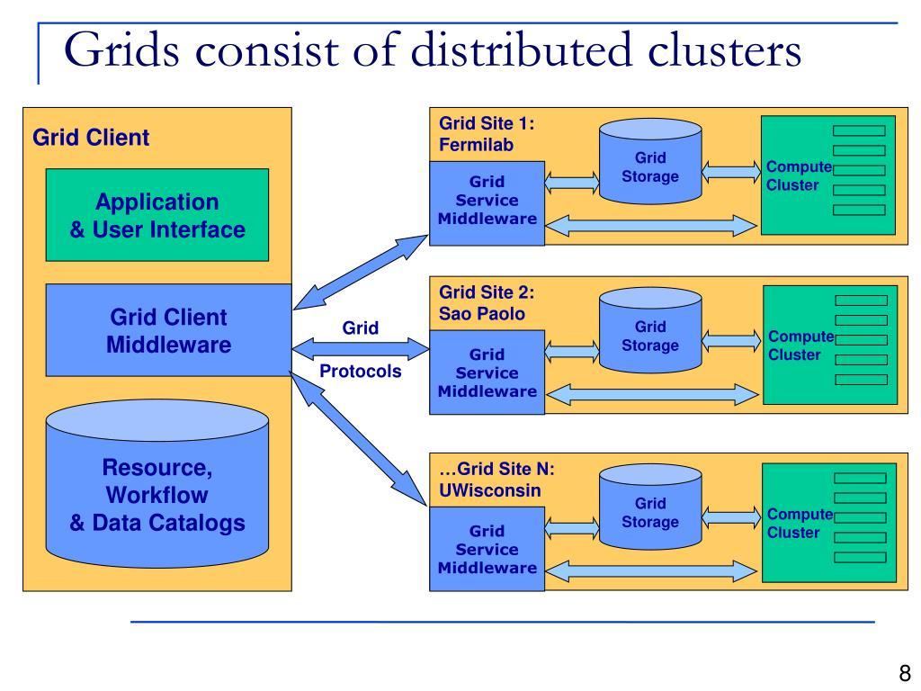
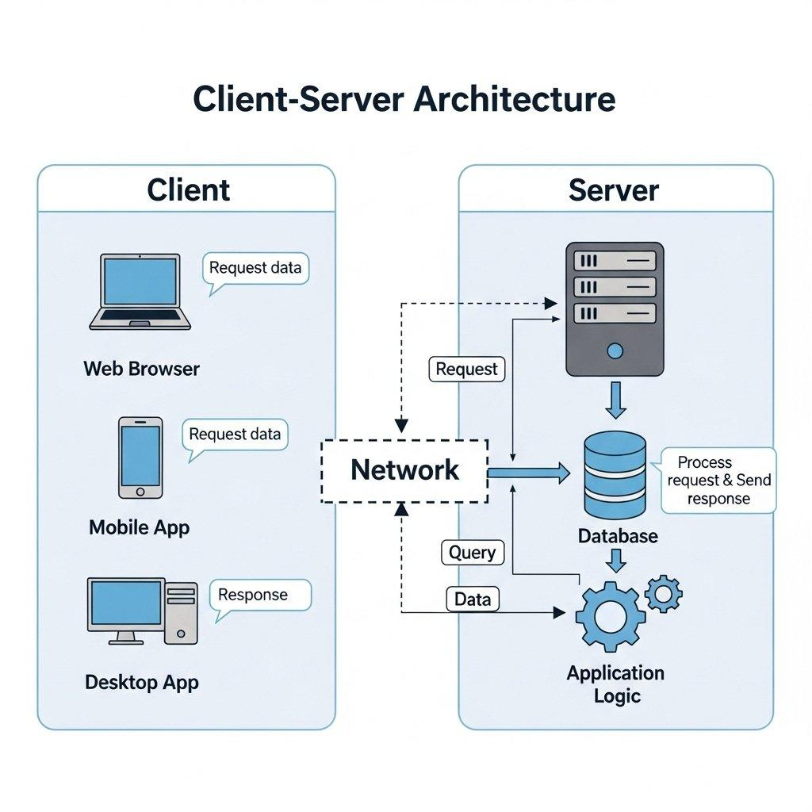
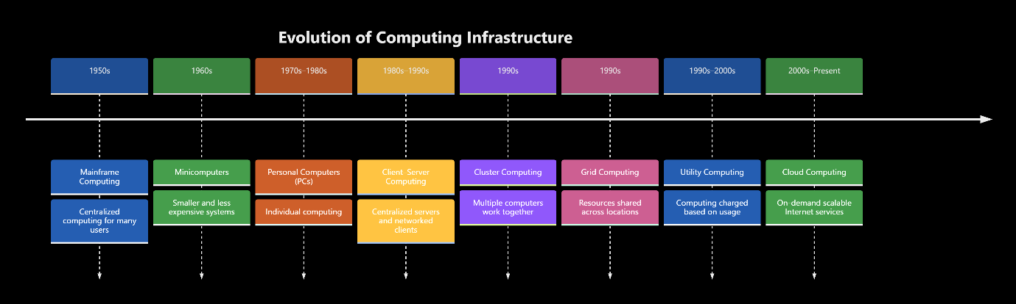

Explanation of Each Stage
Stage | Evolution and Limitation Solved
Mainframe Computing | A centralized powerful computer served many users. It reduced the need for individual computers but was expensive and difficult to scale.
Minicomputers | Smaller and less expensive than mainframes. They enabled departments to use their own computing systems.
Personal Computers (PCs) | Provided individual computing power and reduced dependence on centralized systems. However, resources were often isolated.
Client–Server Computing | Connected clients to centralized servers for data and application sharing. However, server capacity was limited.
Cluster Computing | Connected multiple computers to work as a single system, improving performance and availability.
Grid Computing | Shared computing resources across different locations and organizations, enabling large-scale processing.
Utility Computing | Introduced pay-per-use computing resources, reducing the need for organizations to purchase all infrastructure.
Cloud Computing | Combined virtualization, automation, networking, and utility-based pricing to provide scalable computing services over the Internet.

Hardware Evolution Enabling Cloud Computing
The following hardware advancements made cloud computing possible:
- Multi-core processors: Increased processing power by allowing multiple tasks to execute simultaneously.
- Commodity servers: Low-cost standard servers made it economical to build large-scale computing infrastructure.
- High-capacity storage: Enabled universities to store large volumes of student records, examination data, and learning materials.
- High-speed networking: Enabled fast communication between servers and users across different locations.
- Data centres: Provided centralized facilities containing thousands of servers, storage systems, cooling, power backup, and networking equipment.
These hardware advancements, combined with virtualization, enabled cloud providers to allocate computing resources dynamically to different users.
University Current System – Identification
The university's current system corresponds to traditional on-premise client–server computing.
Reasons:
- The university maintains its own physical servers and computing infrastructure.
- Students and faculty access applications and databases through campus servers.
- Server capacity is limited by the hardware purchased by the university.
- The university is responsible for hardware maintenance, upgrades, backup, and security.
For example, during university examinations or result publication, the existing servers may become overloaded because many students access the system simultaneously.
By adopting cloud computing, the university can dynamically increase server capacity, provide remote access, and reduce the cost of maintaining physical infrastructure.
Conclusion
Computing infrastructure evolved from centralized mainframes to scalable cloud services. Advances in multi-core processors, commodity servers, storage, networking, and data centres enabled this transformation. Cloud computing overcomes the limitations of the university's traditional on-premise client–server system by providing scalable, flexible, and cost-effective resources.
3 – Analyse Internet Software Evolution (3 Marks)
Answer
Introduction
Internet software has evolved from simple static web pages to interactive, dynamic, and cloud-hosted applications. This evolution enables universities to provide online services such as student portals, examination systems, online learning platforms, and fee payment systems.
Evolution of Internet Software
Stage | Description | Limitation Solved
Static Web Pages | Display fixed HTML content to users. | Provided basic online information but lacked interaction.
Dynamic Web | Uses server-side technologies and databases to generate customized content. | Enabled interactive applications and personalized information.
Web 2.0 | Supports user interaction, collaboration, and content sharing. | Improved communication between students and faculty.
Service-Oriented Architecture (SOA) | Applications are developed using reusable services communicating through standard protocols. | Reduced duplication and improved integration.
Mashups | Combines data and services from multiple sources using APIs. | Enabled integration of different applications.
Cloud-Hosted Applications | Applications run on cloud infrastructure and are accessed through the Internet. | Provides scalability, availability, and reduced infrastructure maintenance.
Role of Internet Technologies in Cloud Services
- Web Browsers: Provide an interface for accessing university applications without installing separate software.
- HTTP/HTTPS: Transfers data between browsers and web servers. HTTPS provides encrypted communication.
- AJAX: Enables web pages to update data asynchronously without reloading the entire page.
- APIs: Allow different applications to communicate and exchange data securely.
For example, a university student portal can use APIs to connect student records, attendance, examination results, and online payment services.
Comparison of Software Types
Feature | Desktop Software | Client–Server Software | Web-Delivered Software
Installation | Installed on individual computers | Client software may require installation | Usually accessed through a browser
Access | Individual computer | Connected clients | Anywhere through the Internet
Data Storage | Local storage | Centralized server | Cloud-based storage
Scalability | Limited | Depends on server capacity | Easily scalable using cloud resources
Maintenance | Updated individually | Managed by server and client systems | Centrally managed
Example | MS Word desktop | University LAN-based application | Cloud-based student portal
Impact on University Application Design
The evolution of Internet software supports the university in the following ways:
- Centralized Access: Students and faculty can access university applications through web browsers.
- Dynamic Applications: Student attendance, examination results, and fee details can be updated in real time.
- Application Integration: APIs can connect the student portal, learning management system, and payment gateway.
- Scalability: Cloud-hosted applications can handle increased traffic during admissions and examinations.
- Improved User Experience: AJAX enables faster updates without reloading the entire webpage.
Proposed Design for the University
The university should develop a cloud-hosted web application using a browser-based frontend, backend APIs, and a centralized cloud database.

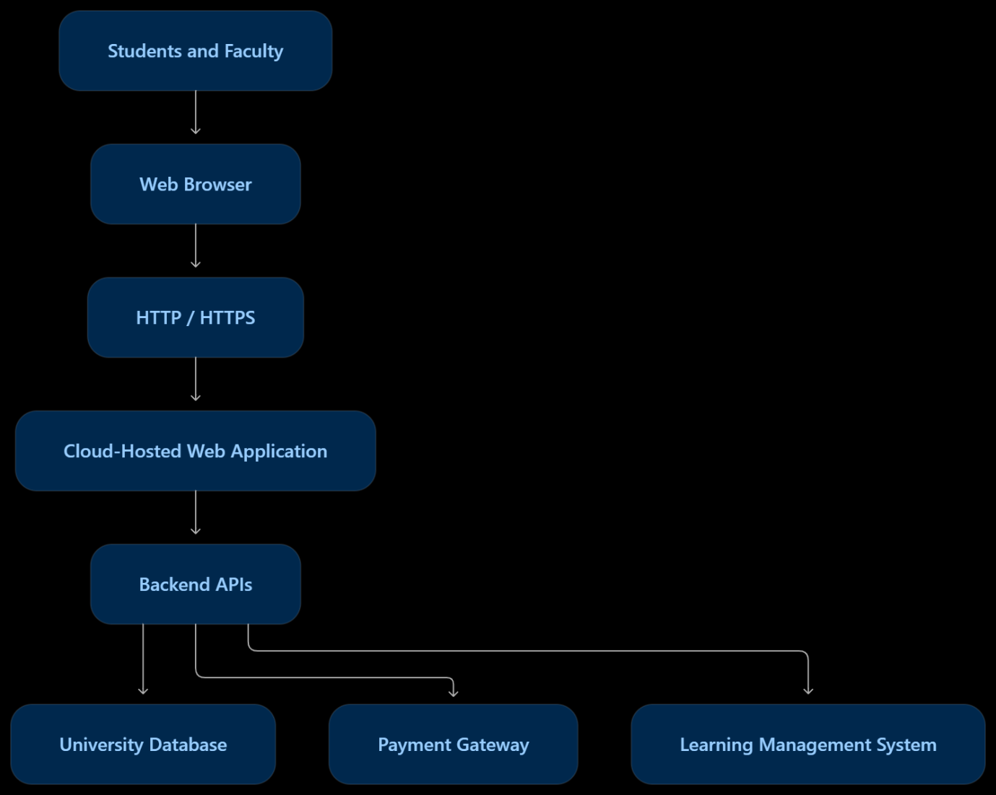

Conclusion
Internet software evolved from static web pages to interactive, API-based, cloud-hosted applications. Technologies such as browsers, HTTP, AJAX, and APIs enable efficient software delivery over the Internet. This evolution helps the university develop scalable, accessible, and integrated applications for students and faculty.
4 – Apply Server Virtualization (5 Marks)
Answer
Introduction
Server virtualization is a technology that allows multiple virtual machines (VMs) to run on a single physical server. It uses a software layer called a hypervisor to divide the physical server's CPU, memory, storage, and network resources among multiple virtual machines.
The university currently has 12 physical servers with low average utilization. By applying server virtualization, the university can consolidate its servers, reduce hardware costs, improve resource utilization, and simplify server management.
Hypervisor and Its Working
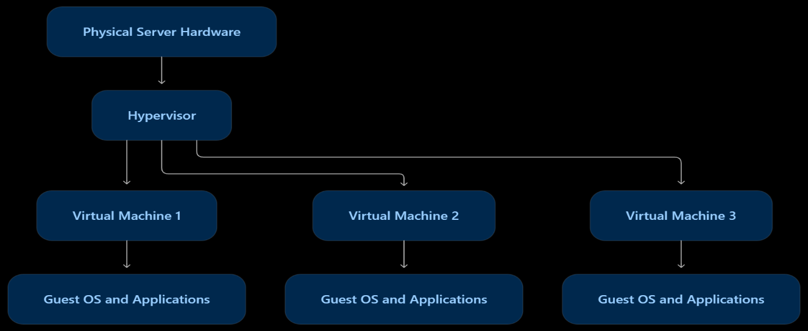
A hypervisor is software or firmware that creates and manages virtual machines. Each VM has its own virtual CPU, memory, operating system, storage, and applications.
The hypervisor allocates physical resources to virtual machines and keeps their execution environments isolated.
Types of Hypervisors
Type | Description | Examples
Type-1 (Bare-Metal) | Runs directly on physical hardware. Provides better performance and is suitable for data centres. | VMware ESXi, Microsoft Hyper-V, Xen
Type-2 (Hosted) | Runs on top of a host operating system. Suitable for development and testing. | Oracle VirtualBox, VMware Workstation
Recommended: Type-1 hypervisor, because the university requires reliable, efficient, and secure server consolidation.
Types of Server Virtualization
Virtualization Type | Explanation | University Application
Full Virtualization | Provides a complete virtual hardware environment for an unmodified guest OS. | Student information system and examination server.
Para-Virtualization | Guest OS is modified to communicate with the hypervisor for improved efficiency. | Specialized Linux applications requiring efficient virtualization.
OS-Level Virtualization (Containers) | Multiple isolated containers share the same host OS kernel. | Web applications, APIs, and university portal services.
Hardware-Assisted Virtualization | Uses processor features such as Intel VT-x and AMD-V to improve virtualization performance. | Database servers and critical university applications.
Proposed Virtualization Plan for the University
The university has 12 physical servers. The following plan can be used to consolidate them.
Application | Proposed Virtualization | Reason
Student Information System | Virtual Machine | Requires a separate OS and strong isolation.
Examination Management System | Virtual Machine | Provides isolation and reliable resource allocation.
University Database Server | Virtual Machine | Supports dedicated memory and CPU allocation.
Web Server | Container | Lightweight and easy to scale.
Learning Management System | Containers | Supports rapid deployment and scaling.
University APIs | Containers | Easy to update and manage independently.
File and Backup Server | Virtual Machine | Requires dedicated storage management.
Development and Testing Applications | Containers | Fast creation and removal of environments.
A Type-1 hypervisor can host the VMs, while containers can run inside suitable VMs. This provides a combination of strong isolation and efficient application deployment.
Server Consolidation Calculation
Given:
- Number of physical servers = 12
- Average CPU utilization per server = 15%
- Target host utilization = 70%
Step 1: Calculate total current workload
Assume each physical server has equal CPU capacity, and the average utilization is measured against that capacity.
\[ \text{Total Workload}=12\times15\% \]
\[ =12\times0.15=1.8 \]
Therefore, the total workload is equivalent to 1.8 fully utilized physical servers.
Step 2: Calculate the required physical hosts
Each new host should operate at a maximum target utilization of 70%.
\[ \text{Required Hosts}= \frac{\text{Total Workload}}{\text{Target Utilization}} \]
\[ =\frac{1.8}{0.70} \]
\[ =2.57 \]
Since the number of physical hosts must be a whole number, round up:
\[ \boxed{\text{Required Physical Hosts}=3} \]
Step 3: Calculate consolidation ratio
\[ \text{Consolidation Ratio}= \frac{\text{Original Servers}}{\text{New Hosts}} \]
\[ =\frac{12}{3} \]
\[ \boxed{4:1} \]
Final Result: The university can consolidate 12 physical servers into approximately 3 physical hosts, achieving a 4:1 consolidation ratio.
Note: This is an idealized estimate based on equal server capacity and average CPU utilization. Actual host sizing must also consider RAM, storage, network capacity, peak workload, and high availability.
Benefits of Virtualization
Live Migration: Moves a running VM from one physical host to another with minimal downtime. It supports hardware maintenance without interrupting university services.
Snapshots: Capture the state of a VM at a particular time. They help restore the VM after configuration errors or software failures. Snapshots are not a replacement for backups.
Resource Over-Commitment: Allows the hypervisor to allocate more virtual CPU or memory resources than the physical hardware contains, assuming all VMs do not use their maximum resources simultaneously. It improves resource utilization but must be monitored carefully.
Risks of Virtualization
Risk | Explanation | Solution
Noisy Neighbour | One VM consumes excessive resources, affecting other VMs. | Apply resource limits and reservations.
Hypervisor Failure | Failure of the hypervisor may affect all VMs on that host. | Use redundant hosts and high-availability clustering.
Security Isolation | A vulnerability may allow an attacker to access other VMs. | Apply security patches, access controls, and network isolation.
Resource Over-Commitment | Excessive allocation may cause CPU or memory shortages. | Monitor utilization and maintain sufficient capacity.
Conclusion
Server virtualization enables the university to consolidate 12 underutilized physical servers into approximately 3 physical hosts, achieving a 4:1 consolidation ratio under the given assumptions. Using a Type-1 hypervisor, virtual machines, and containers improves resource utilization, reduces hardware costs, and simplifies infrastructure management. Live migration, snapshots, and high availability further improve the reliability of university services.
5 – Apply Web Services (4 Marks)
Answer
Introduction to Web Services
A web service is a software component that enables two applications to communicate and exchange data over a network using standard protocols such as HTTP or HTTPS.
Web services play an important role in cloud computing and Service-Oriented Architecture (SOA) by allowing different university systems to communicate, share information, and reuse services without depending on a particular programming language or platform.
For example, the university student portal can communicate with the examination system, fee payment gateway, and library management system through web services.
Types of Web Services and Related Technologies
Technology | Description
SOAP (Simple Object Access Protocol) | A protocol that exchanges structured XML messages. It supports formal contracts and enterprise-level security features.
WSDL (Web Services Description Language) | An XML-based document that describes a SOAP service, its operations, messages, and endpoint.
UDDI (Universal Description, Discovery and Integration) | A registry standard used to publish and discover web services.
REST (Representational State Transfer) | An architectural style that uses HTTP methods to access and manipulate resources. RESTful services commonly exchange JSON or XML data.
SOAP vs RESTful Web Services
Feature | SOAP | REST
Type | Protocol | Architectural style
Data Format | XML | JSON, XML, and other formats
Communication | SOAP messages | HTTP methods
Performance | Generally heavier due to XML processing | Generally lightweight and faster
Security | Supports WS-Security | Commonly uses HTTPS, OAuth, and tokens
Best Use | Enterprise and formal transaction systems | Web applications, mobile apps, and APIs
HTTP Methods in REST
- GET: Retrieves information.
- POST: Creates a resource or performs an operation.
- PUT: Replaces or updates a resource.
- DELETE: Removes a resource.
RESTful services are suitable for university applications because they are simple, scalable, and easy to integrate with web and mobile applications.
Proposed University Web Services
The university can expose its functions as web services so that students, faculty, and external systems can access them through secure APIs.
Web Service 1: Student Examination Result Lookup
Purpose: Allows students to retrieve their examination results through the university portal.
- Service Type: REST
- Endpoint: /api/v1/results/{studentId}
- HTTP Method: GET
- Data Format: JSON
Sample Response:
{
"studentId": "1025",
"studentName": "Arun",
"semester": 3,
"results": [
{
"subject": "Machine Learning",
"marks": 85,
"grade": "A"
},
{
"subject": "Computer Networks",
"marks": 90,
"grade": "A+"
}
]
}
Justification: REST is suitable because result lookup is a read-only operation. GET requests are lightweight, easy to implement, and suitable for web and mobile applications.
Web Service 2: University Fee Payment
Purpose: Enables students to pay semester fees through an integrated payment gateway.
- Service Type: REST
- Endpoint: /api/v1/payments
- HTTP Method: POST
- Data Format: JSON
Sample Request:
{
"studentId": "1025",
"amount": 45000,
"paymentMethod": "UPI",
"paymentToken": "TOKEN123"
}
Sample Response:
{
"paymentId": "PAY1001",
"studentId": "1025",
"amount": 45000,
"status": "SUCCESS",
"transactionId": "TXN98765"
}
Justification: REST is suitable for integrating the university portal with modern payment gateways. HTTPS, authentication, and idempotency keys should be used to protect transactions and prevent duplicate payments.
Sensitive payment information should be handled by the payment gateway rather than stored directly by the university.
Web Service 3: Library Book Search
Purpose: Allows students to search for books and check their availability in the university library.
- Service Type: REST
- Endpoint: /api/v1/library/books
- HTTP Method: GET
- Data Format: JSON
Sample Request:
GET /api/v1/library/books?title=Machine%20Learning
Sample Response:
{
"books": [
{
"bookId": "B101",
"title": "Machine Learning",
"author": "Tom Mitchell",
"availability": "Available"
}
]
}
Justification: REST is suitable because book searching is a simple retrieval operation. GET requests allow the library system to return results quickly and efficiently.
Web Service 4: Student Attendance Information
Purpose: Allows students to view their attendance details.
- Service Type: REST
- Endpoint: /api/v1/attendance/{studentId}
- HTTP Method: GET
- Data Format: JSON
Sample Request:
GET /api/v1/attendance/1025
Sample Response:
{
"studentId": "1025",
"semester": 3,
"attendancePercentage": 92,
"status": "Eligible"
}
Justification: REST is suitable because attendance information is frequently accessed by students and faculty. It provides a simple and efficient method of retrieving data.
SOAP-Based Service Example
SOAP can be used when a university needs strict message contracts and formal transaction processing, particularly for integration with legacy enterprise systems.
For example, a fee payment SOAP service may use a WSDL document to define its operations and request/response structure.
Sample SOAP Request:
<soap:Envelope
xmlns:soap="http://schemas.xmlsoap.org/soap/envelope/">
<soap:Body>
<ProcessFeePayment>
<StudentID>1025</StudentID>
<Amount>45000</Amount>
</ProcessFeePayment>
</soap:Body>
</soap:Envelope>
Sample SOAP Response:
<soap:Envelope
xmlns:soap="http://schemas.xmlsoap.org/soap/envelope/">
<soap:Body>
<ProcessFeePaymentResponse>
<Status>SUCCESS</Status>
<TransactionID>TXN98765</TransactionID>
</ProcessFeePaymentResponse>
</soap:Body>
</soap:Envelope>
SOAP is appropriate for systems that require formal contracts, XML-based messaging, and WS-Security. However, it is generally more complex than REST.
Proposed University Web Service Architecture

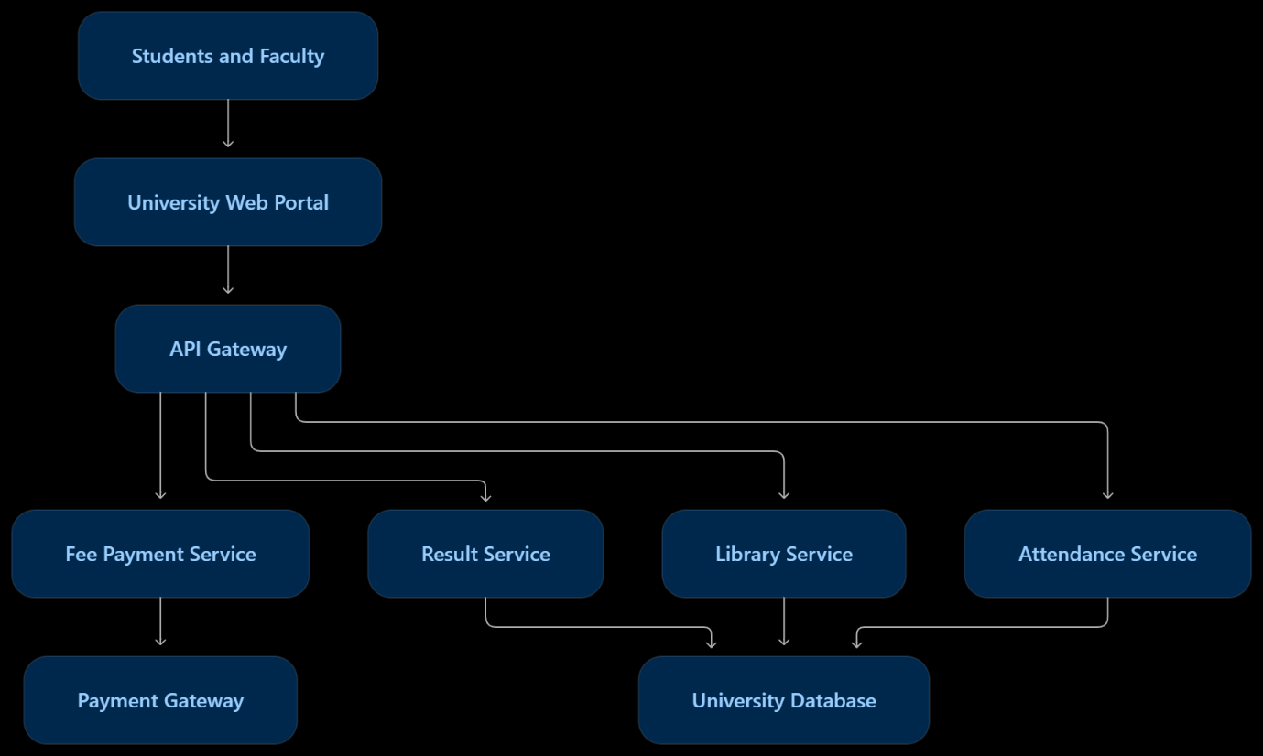
The API Gateway provides a common entry point for university services. It can handle authentication, authorization, request routing, and monitoring.
Conclusion
Web services enable the university to integrate its examination, payment, library, and attendance systems through standardized communication. REST is recommended for most university functions because it is lightweight, scalable, and easy to integrate with cloud applications. SOAP is suitable for enterprise systems requiring formal service contracts and advanced messaging security. This approach improves interoperability, accessibility, and application reusability.
6 – Analyse the Service Models: IaaS, PaaS and SaaS (5 Marks)
Answer
Introduction
Cloud computing provides services through three major service models: Infrastructure as a Service (IaaS), Platform as a Service (PaaS), and Software as a Service (SaaS).
These models differ in the level of control provided to the university and the amount of infrastructure management handled by the cloud provider.
For the university, selecting the appropriate service model for each application helps reduce maintenance costs, improve scalability, and provide efficient services to students and faculty.
Definition of IaaS, PaaS and SaaS
Infrastructure as a Service (IaaS):
IaaS provides virtualized computing resources such as virtual machines, storage, and networking over the Internet. The university manages the operating system, middleware, applications, and data, while the provider manages the physical infrastructure.
Example: Amazon Web Services (AWS) EC2.
Platform as a Service (PaaS):
PaaS provides a complete platform for developing, deploying, and managing applications without managing the underlying servers or operating systems.
Example: Google App Engine.
Software as a Service (SaaS):
SaaS provides ready-to-use software applications through the Internet. The provider manages the infrastructure, platform, application, and updates.
Example: Microsoft 365.
Layer-Wise Responsibility Comparison
The following table shows who manages each layer in the three service models.
Computing Layer | IaaS | PaaS | SaaS
Application | University | University | Cloud Provider
Data | University | University | Shared responsibility
Runtime and Middleware | University | Cloud Provider | Cloud Provider
Operating System | University | Cloud Provider | Cloud Provider
Virtualization | Cloud Provider | Cloud Provider | Cloud Provider
Servers, Storage, Networking | Cloud Provider | Cloud Provider | Cloud Provider
Explanation:
- In IaaS, the university has greater control because it manages the operating system and applications.
- In PaaS, the provider manages the operating system and platform, allowing developers to focus on application development.
- In SaaS, the provider manages almost the entire application stack, while the university mainly manages users, access permissions, and its data-related responsibilities.
Categorization of University Applications
The university has five major applications: Student Information System (SIS), Learning Management System (LMS), Library Management System, Examination Portal, and Email System.
University Application | Proposed Service Model | Example Provider | Reason
Student Information System (SIS) | IaaS | AWS EC2 | Requires customized student records, database control, and integration with existing university systems.
Learning Management System (LMS) | PaaS | Google App Engine | Supports application development, automatic scaling, and integration with online learning services.
Library Management System | SaaS | Ex Libris Alma | Provides ready-made library management functions such as cataloguing, circulation, and resource management.
Examination Portal | PaaS | Microsoft Azure App Service | Supports custom examination applications and scaling during examination periods.
Email System | SaaS | Microsoft 365 | Provides ready-to-use email, calendar, collaboration, and storage services without server maintenance.
Reasoning Behind the Categorization
Student Information System – IaaS
The SIS stores sensitive information such as student profiles, academic records, attendance, and fee details. The university may require customized software, database configurations, and integration with existing systems.
IaaS is suitable because it provides control over the operating system, database environment, and application configuration. The university can also migrate its existing application to virtual machines without completely redesigning it.
Learning Management System – PaaS
The LMS provides online courses, assignments, study materials, quizzes, and faculty-student interaction. A university may develop a customized LMS to meet its academic requirements.
PaaS is suitable because developers can deploy and update the application without managing physical servers or operating systems. Resources can be scaled during assignment submissions and online examinations.
Library Management System – SaaS
The library system manages book catalogues, borrowing, returns, reservations, and digital resources.
SaaS is suitable because a ready-made library management application reduces development and maintenance effort. The university can use the provider's software and configure it according to its library requirements.
Examination Portal – PaaS
The examination portal handles question papers, student login, online tests, submissions, and results.
PaaS is suitable because the examination application may require custom development and must handle sudden increases in users during examinations. Automatic scaling and managed deployment help maintain performance.
Email System – SaaS
The email system supports communication between students, faculty, and administrative staff.
SaaS is suitable because the university does not need to maintain email servers, configure mail infrastructure, or manage software updates. A provider such as Microsoft 365 can deliver email and collaboration services.
Comparison of IaaS, PaaS and SaaS
Factor | IaaS | PaaS | SaaS
Control | High | Medium | Low
Cost | Pay for infrastructure usage; additional IT staff costs | Pay for platform and resource usage | Subscription-based pricing
Scalability | Flexible, but requires configuration | Usually easy through managed scaling | Provider-managed scaling
Maintenance Effort | High | Medium | Low
Vendor Lock-in | Low to medium | Medium to high | High
Best Suitable For | Customized applications and legacy systems | Application development and deployment | Ready-to-use applications
Analysis of the Comparison
Control: IaaS provides the highest control because the university manages the operating system, middleware, and applications. PaaS provides control over application development but not the underlying infrastructure. SaaS provides the least control because the provider manages the software.
Cost: IaaS reduces hardware purchasing costs but requires technical staff for maintenance. PaaS reduces server administration costs. SaaS generally has lower initial costs because the university pays for a subscription instead of developing and maintaining software.
Scalability: IaaS requires administrators to configure resources. PaaS provides managed scaling for applications. SaaS providers manage the scaling of their applications according to service demand.
Maintenance Effort: IaaS requires the university to maintain operating systems and applications. PaaS reduces maintenance by managing the operating system and runtime. SaaS requires the least maintenance because the provider manages software updates and infrastructure.
Vendor Lock-in: IaaS generally provides greater portability because virtual machines and applications can be migrated between providers, although migration may still require changes. PaaS can create dependency on provider-specific tools and APIs. SaaS may create stronger lock-in because data formats, workflows, and integrations can depend on the provider.
Real-World Provider Examples
AWS Signature Version 4 - Overview (ODC) | OutSystems
IaaS – Amazon Web Services (AWS)
AWS EC2 provides virtual machines, networking, and storage. The university can install and manage its own operating system and applications.
Shortcomings of Google App Engine - Sachin Rekhi
PaaS – Google App Engine
Provides a managed application platform for deploying web applications without managing the underlying servers.
Microsoft 365 Business Standard - Software ufficio - LDLC | Misericordia
SaaS – Microsoft 365
Provides ready-to-use email, office applications, file storage, and collaboration services.
Conclusion
IaaS, PaaS, and SaaS provide different levels of control, scalability, and maintenance. For the university, IaaS is suitable for the customized Student Information System, PaaS is suitable for the LMS and Examination Portal, and SaaS is suitable for the Library Management System and Email System.
A combination of these service models enables the university to maintain control over critical applications while reducing infrastructure costs, improving scalability, and simplifying application management.
7 – Examine XaaS (Anything-as-a-Service) (3 Marks)
Answer
Introduction to XaaS
XaaS stands for Anything-as-a-Service. It is a cloud computing concept in which various IT resources, applications, and services are delivered over the Internet on a subscription or pay-per-use basis.
XaaS allows the university to use services without purchasing and maintaining expensive hardware or software. It improves flexibility, scalability, and cost efficiency.
Variants of XaaS
XaaS Variant | Description | University Application
DaaS (Desktop-as-a-Service) | Provides virtual desktops over the Internet. | Students and faculty can access university desktops from anywhere.
BaaS / MBaaS (Backend-as-a-Service) | Provides backend services such as authentication, databases, and APIs. | Supports mobile applications for attendance and student services.
FaaS (Function-as-a-Service) | Executes code in response to events without managing servers. | Sends automatic notifications for examination results and fee deadlines.
DBaaS (Database-as-a-Service) | Provides managed database services. | Stores student records, attendance, and examination results.
Security-as-a-Service | Provides cloud-based security services such as threat detection and access protection. | Protects university applications and student information.
DRaaS (Disaster-Recovery-as-a-Service) | Provides cloud-based backup and recovery infrastructure. | Restores university services after server failure or disasters.
Two Recommended XaaS Offerings for the University
Disaster-Recovery-as-a-Service (DRaaS)
DRaaS provides backup and recovery capabilities through cloud infrastructure.
Benefits:
- Protects student records, examination data, and financial information.
- Enables recovery after hardware failure, cyberattacks, or natural disasters.
- Reduces downtime of university applications.
- Supports business continuity and data availability.
Justification: The university handles important academic and administrative data. DRaaS provides a reliable recovery solution without requiring a separate physical disaster recovery centre.
Database-as-a-Service (DBaaS)
DBaaS provides managed database services without requiring the university to maintain database servers.
Benefits:
- Reduces database maintenance effort.
- Provides automated backups and updates.
- Supports scalability during admissions and examinations.
- Improves database availability and performance.
Justification: The university's Student Information System, Examination Portal, and Library Management System require reliable databases. DBaaS reduces administration effort and provides scalable storage for increasing student records.
Risks of Over-Reliance on Multiple XaaS Providers
- Vendor Lock-in: Switching providers may be difficult due to different APIs, data formats, and service configurations.
- Integration Complexity: Connecting services from multiple providers may require additional development and configuration.
- Security Risks: Sensitive university data may be distributed across multiple providers, increasing the complexity of security management.
- Cost Management: Multiple subscriptions and usage-based charges may increase operational expenses.
- Service Dependency: If a provider experiences an outage, the university's applications may become unavailable.
Conclusion
XaaS enables the university to access flexible and scalable IT services without maintaining extensive physical infrastructure. DRaaS and DBaaS are recommended because they improve data protection, recovery, availability, and database management. However, the university should carefully manage provider dependencies, security, integration, and costs to avoid excessive reliance on multiple cloud services.
TASK 8 – Design the Cloud Solution Architecture (5 Marks)
Answer
Introduction
The university currently faces challenges such as limited server capacity, high infrastructure maintenance costs, difficulty handling peak workloads, and the risk of data loss.
To overcome these problems, a cloud-based architecture is proposed by combining server virtualization, web services, cloud service models, auto-scaling, and disaster recovery.
The proposed solution uses a Hybrid Cloud Deployment Model to provide scalability, security, availability, and efficient resource utilization.

Component Selection and Service Models
The university architecture uses a combination of IaaS, PaaS, and SaaS to meet different application requirements.
Architecture Component | Proposed Deployment | Service Model | Justification
User Access | Public Cloud | SaaS | Students and faculty access services through web browsers.
Load Balancer | Public Cloud | PaaS | Distributes incoming requests across application servers.
Web Tier | Public Cloud | IaaS / PaaS | Supports scalable web servers and application hosting.
API Gateway | Public Cloud | PaaS | Provides centralized API access, authentication, and request routing.
Application Tier | Hybrid Cloud | IaaS | Runs university applications using virtual machines and containers.
Database Tier | Private Cloud | DBaaS | Protects sensitive student records and examination data.
Storage | Hybrid Cloud | IaaS / Storage-as-a-Service | Stores documents, learning materials, and backups.
Email System | Public Cloud | SaaS | Provides managed email and collaboration services.
Disaster Recovery | Separate Cloud Region | DRaaS | Supports recovery of university applications and data after a disaster.
Explanation of Architecture Components
User Layer: Students, faculty, and administrators access the university portal using computers, laptops, and mobile devices.
Load Balancer: Distributes incoming traffic across multiple web servers. It prevents a single server from becoming overloaded and improves availability.
Web and Application Tier: Web servers handle user requests, while application servers execute university functions such as student registration, attendance, examination management, and fee payment. Virtual machines provide isolation, and containers support lightweight application deployment.
API Layer: The API Gateway connects the web application with backend services. RESTful APIs are used for result lookup, fee payment, library search, and attendance management.
Database Tier: Stores student records, examination results, attendance, and financial information. A managed database service provides automated backups, monitoring, and scalability.
Storage Tier: Cloud object storage stores documents, assignments, learning materials, and backup files.
Disaster Recovery Region: A geographically separate cloud region stores replicated data and recovery resources. It enables the university to restore critical services if the primary region becomes unavailable.
Elasticity and Auto-Scaling
The university experiences high traffic during admissions, examinations, and result publication.
Auto-scaling automatically increases or decreases computing resources according to workload.
Example:
- During admissions, additional application instances are created to handle student registration.
- During online examinations, additional resources are allocated to the examination portal.
- After peak periods, unnecessary instances are removed to reduce costs.
This provides efficient resource utilization and prevents application slowdowns.
Security and Availability Measures
Security / Availability Measure | Implementation
Access Control | Role-Based Access Control (RBAC) for students, faculty, and administrators.
Encryption | HTTPS/TLS for data in transit and encryption at rest for databases and storage.
Multi-Zone Deployment | Deploy application servers across multiple availability zones.
Backup | Automated database backups and periodic recovery testing.
Disaster Recovery | Replicate critical data to a geographically separate region.
Network Security | Firewalls, private subnets, and restricted database access.
Monitoring | Monitor server health, traffic, resource usage, and security events.
High Availability | Load balancing, health checks, and automatic replacement of failed instances.
Justification of Design Decisions
The hybrid cloud model is selected because the university requires both scalability and security. Public cloud resources can handle web traffic and application workloads, while private cloud infrastructure can protect sensitive student and examination records.
Virtualization enables multiple university applications to share physical infrastructure efficiently. Web services allow different systems to communicate through standardized APIs. IaaS, PaaS, and SaaS reduce infrastructure management effort according to each application's requirements.
Multi-zone deployment improves availability, while a separate disaster recovery region protects against regional failures. Auto-scaling supports admissions and examination peaks without requiring permanent additional hardware.
Conclusion
The proposed cloud architecture combines virtualization, web services, and cloud service models to create a scalable, secure, and highly available university system. The hybrid cloud deployment provides flexibility, while auto-scaling, multi-zone deployment, encryption, and disaster recovery improve performance, security, and business continuity. This architecture reduces infrastructure costs and supports the university's growing academic and administrative requirements.
9 – Hands-on Implementation and Documentation (4 Marks)
Answer
Aim
To implement a small proof-of-concept (PoC) of the proposed university cloud architecture by hosting a web application or REST API using a virtual machine or container, deploying a cloud-based component, and testing the application using a client.
Proposed Proof-of-Concept
The following implementation demonstrates a simple University Student Result API.
The API allows students to retrieve their examination results using a student ID.
Tools and Technologies Used
Component | Technology
Virtualization | Docker
Backend | Python Flask
Web Service | REST API
Database | SQLite
Client | Web Browser / curl
Cloud Component | Cloud-hosted static website or managed database
Operating System | Windows / Linux
The implementation can be performed locally using Docker or VirtualBox. A free-tier cloud account can also be used to deploy the application online.
Implementation Steps
Step 1: Create the Project
Create a folder named university-cloud-poc.
Inside the folder, create the following files:

university-cloud-poc/
│
├── app.py
├── requirements.txt
└── Dockerfile
Step 2: Develop the REST API
Step 3: Create the Requirements File
Create requirements.txt.
Flask
Step 4: Create the Dockerfile
Create a file named Dockerfile.

FROM python:3.12-slim

WORKDIR /app

COPY requirements.txt .

RUN pip install --no-cache-dir -r requirements.txt

COPY app.py .

EXPOSE 5000

CMD ["python", "app.py"]
This Dockerfile creates a container image containing Python, Flask, and the university REST API.
Step 5: Build and Run the Container
Install Docker Desktop and ensure that Docker is running.
Open PowerShell in the project folder and execute:
Build the Docker image:
docker build -t university-cloud-poc .
Run the container:
docker run -d -p 5000:5000 --name university-api university-cloud-poc
Check the running container:
docker ps
The container should be running and listening on port 5000.
Step 6: Test the REST API
Open a web browser and enter:
http://localhost:5000
Expected output:
BROWSER OUTPUT — HOME PAGE
University Cloud Application
Student Result REST API is running.
Try: /api/results/1025
Now enter the following URL:
http://localhost:5000/api/results/1025
Expected JSON response:

{
"studentId": "1025",
"studentName": "Arun",
"semester": 3,
"subjects": [
{
"subject": "Machine Learning",
"marks": 85,
"grade": "A"
},
{
"subject": "Computer Networks",
"marks": 90,
"grade": "A+"
},
{
"subject": "Cloud Computing",
"marks": 88,
"grade": "A"
}
]
}
Testing Using curl
Execute the following command in PowerShell:
curl.exe http://localhost:5000/api/results/1025
To test an invalid student ID:
curl.exe http://localhost:5000/api/results/9999
Expected response:
{
"error": "Student not found"
}
The second request should return HTTP status code 404.
Step 7: Deploy a PaaS Component
For the cloud-hosted component, the university can deploy the Flask REST API using a managed application platform such as Render.
This demonstrates PaaS because the platform manages the underlying server infrastructure.
Deployment procedure:
- Create a GitHub repository named university-cloud-poc.
- Upload app.py and requirements.txt.
- Create an account on Render and connect the GitHub repository.
- Select the option to create a new web service.
- Configure the deployment:
  - Runtime: Python
  - Build command: pip install -r requirements.txt
  - Start command: gunicorn app:app
- Add gunicorn to requirements.txt:
Flask
gunicorn
- Deploy the application.
- Open the public application URL provided by the platform.
The deployed API can then be tested using:
https://your-service-url/api/results/1025
Replace your-service-url with the actual URL provided after deployment.
Note: The above is a deployment procedure, not a claim that the application has already been deployed. Availability of free hosting plans may change.
Step 8: Screenshots and Documentation
The following screenshots should be captured during implementation and included in the assignment report.
Screenshot 1 – Docker Image Creation
Capture the PowerShell terminal showing the successful docker build command.
Caption: Docker image created successfully for the university application.
Screenshot 2 – Running Container
Capture the output of docker ps showing the running university API container.
Caption: University REST API running inside a Docker container.
Screenshot 3 – REST API Response
Capture the browser displaying the JSON result for student ID 1025.
Caption: Successful retrieval of student examination results using a REST API.
Screenshot 4 – PaaS Deployment
Capture the cloud hosting dashboard showing the successful deployment and the public application URL.
Caption: University REST API deployed on a cloud application platform.
Issues Faced and Solutions
Issue | Solution
Docker command not recognized | Install Docker Desktop and restart the terminal.
Port 5000 already in use | Run the container using another host port, such as -p 5001:5000.
Container exits immediately | Check the application logs using docker logs university-api.
API returns 404 | Verify the endpoint and student ID.
Cloud deployment fails | Check the build command, dependencies, and application start command.
Result
The University Student Result REST API was designed using Python Flask and Docker. The application provides student examination results through a REST endpoint and returns JSON responses.
The proof-of-concept demonstrates:
- Server virtualization using a Docker container.
- RESTful web service implementation.
- Client testing through a browser or curl.
- Cloud application deployment using a PaaS platform.
- A basic example of the university's proposed cloud architecture.
Conclusion:
The proof-of-concept demonstrates how a university function can be hosted using containerization and cloud application services. Docker provides an isolated application environment, REST APIs enable communication between systems, and PaaS simplifies deployment and infrastructure management. The implementation can be extended with a database, authentication, and additional university services.
10 – Evaluate and Recommend the Final Cloud Solution
Answer
Introduction
The university currently operates 12 physical servers with an average utilization of only 15%. This results in inefficient resource utilization, high hardware maintenance costs, limited scalability, and difficulty handling peak workloads during admissions and examinations.
Based on the previous tasks, three possible infrastructure options are evaluated:
- Traditional on-premise infrastructure.
- IaaS-based cloud infrastructure.
- PaaS/SaaS-based cloud infrastructure.
The final solution should provide cost efficiency, scalability, security, high availability, and reliable management of university applications.
Comparison of Infrastructure Options
Evaluation Factor | On-Premise | IaaS-Based Cloud | PaaS/SaaS-Based Cloud
Cost | High CapEx for hardware, maintenance, and upgrades. | Mainly OpEx through usage-based billing. | Subscription or usage-based OpEx.
Scalability | Limited by physical server capacity. | Flexible; virtual machines can be added or removed. | High scalability through managed platforms and services.
Availability | Depends on university infrastructure and backup systems. | Supports multi-zone deployment and high availability. | Provider-managed availability, depending on service configuration.
Security | Full infrastructure control, but university manages all security. | Shared responsibility between provider and university. | Provider manages more security layers; university manages access and data responsibilities.
Maintenance Effort | High; requires hardware and system administration. | Medium; operating systems and applications require maintenance. | Low; providers manage most infrastructure and platform maintenance.
Control | Highest control. | High control over virtual machines and operating systems. | Less infrastructure control.
Suitability | Suitable for existing legacy applications. | Suitable for customized applications. | Suitable for standard applications and managed services.
Analysis
On-Premise Infrastructure: Provides complete control over hardware and data, but requires high initial investment. It is less suitable for the university because the existing 12 servers have low utilization and cannot easily handle sudden increases in workload.
IaaS-Based Cloud: Provides virtual machines, storage, and networking. It reduces hardware purchasing costs and supports scalability. However, the university must manage operating systems, application updates, and security configurations.
PaaS/SaaS-Based Cloud: Reduces infrastructure management effort. PaaS supports customized application development, while SaaS provides ready-to-use applications. It is suitable for applications such as email, library management, and online learning.
Therefore, a combination of IaaS, PaaS, and SaaS provides the best balance of control, cost, and operational efficiency.
Three-Year Cost Comparison
The following is an illustrative cost estimate for the university. Actual costs depend on provider pricing, region, storage requirements, workload, and the number of users.
Assumptions
- Existing infrastructure consists of 12 physical servers.
- Each physical server costs approximately ₹1.5 lakh.
- Annual on-premise maintenance, electricity, and support cost ₹5 lakh.
- Cloud estimates include computing, storage, networking, and basic backup.
- Costs are estimated in Indian Rupees (INR).
- All estimates are for a three-year period and exclude GST.
- Migration costs are included separately.
Cost Calculation
Option 1: On-Premise Infrastructure
Initial hardware investment:
\[ 12 \times ₹1.5 \text{ lakh}=₹18 \text{ lakh} \]
Three-year maintenance cost:
\[ 3 \times ₹5 \text{ lakh}=₹15 \text{ lakh} \]
Total three-year cost:
\[ ₹18 \text{ lakh}+₹15 \text{ lakh} \]
\[ \boxed{₹33 \text{ lakh}} \]
Option 2: IaaS-Based Cloud
Assume cloud infrastructure costs ₹50,000 per month.
Three-year cloud cost:
\[ ₹50,000 \times 36=₹18 \text{ lakh} \]
Assume migration costs ₹2 lakh and additional administration costs ₹3 lakh per year.
\[ ₹18+₹2+(3\times₹3) \]
\[ \boxed{₹29 \text{ lakh}} \]
Option 3: PaaS/SaaS-Based Cloud
Assume managed cloud services cost ₹55,000 per month.
Three-year service cost:
\[ ₹55,000 \times 36=₹19.8 \text{ lakh} \]
Assume migration and integration costs ₹2.5 lakh.
\[ ₹19.8+₹2.5 \]
\[ \boxed{₹22.3 \text{ lakh}} \]
Three-Year Cost Comparison Table
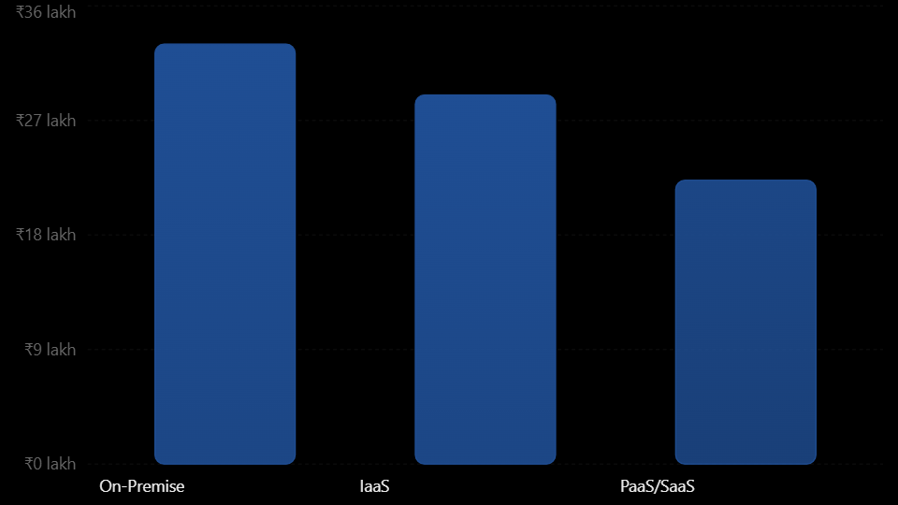
Infrastructure Option | Initial CapEx | Three-Year OpEx and Other Costs | Total 3-Year Cost
On-Premise | ₹18 lakh | ₹15 lakh | ₹33 lakh
IaaS-Based Cloud | ₹0 lakh | ₹29 lakh | ₹29 lakh
PaaS/SaaS-Based Cloud | ₹0 lakh | ₹22.3 lakh | ₹22.3 lakh
Cost Analysis:
- PaaS/SaaS provides the lowest estimated three-year cost.
- IaaS reduces the need for physical hardware but requires more administration.
- On-premise infrastructure requires the highest initial investment.
- PaaS/SaaS reduces maintenance effort and supports faster deployment.
The estimates are illustrative rather than provider quotations. They assume that the university can replace existing applications with managed services without major additional licensing costs.
Main Risks and Mitigation Strategies
Risk | Description | Mitigation Strategy
Vendor Lock-in | The university may become dependent on a specific provider's tools, APIs, and services. | Use open standards, REST APIs, portable containers, and regular data exports.
Data Privacy | Student records, examination results, and financial information may be exposed. | Use encryption, RBAC, MFA, private networks, and appropriate data protection policies.
Downtime | Cloud provider outages or network failures may interrupt university services. | Use multi-zone deployment, load balancing, backups, and disaster recovery in a separate region.
Skills Gap | University IT staff may lack cloud administration and security skills. | Provide cloud training, certifications, and practical workshops.
Cost Overrun | Uncontrolled resource usage may increase cloud bills. | Set budgets, configure billing alerts, and monitor resource consumption.
Data Loss | Accidental deletion or cyberattacks may affect university records. | Maintain automated backups, versioning, and periodic recovery testing.
Risk Analysis
Cloud adoption does not automatically guarantee security or availability. The university must maintain appropriate access controls, monitor cloud resources, and establish clear responsibilities with service providers.
For sensitive data, the university should select a provider and deployment region that meet applicable data protection and institutional requirements.
Final Cloud Solution Recommendation
Based on the previous tasks, the university should adopt a Hybrid Cloud Architecture using IaaS, PaaS, and SaaS.
The solution combines private infrastructure for sensitive information with public cloud services for scalable applications.
Recommended Service Model for Each Application
University Application | Final Recommendation | Reason
Student Information System (SIS) | IaaS | Supports customized applications and greater control over sensitive student records.
Learning Management System (LMS) | PaaS | Enables application development, automatic scaling, and reduced server maintenance.
Library Management System | SaaS | Provides ready-to-use library functions with reduced administration effort.
Examination Portal | PaaS | Supports custom examination applications and high traffic during examinations.
Email System | SaaS | Provides managed communication and collaboration services.
Database | DBaaS | Reduces database administration and supports automated backups.
Disaster Recovery | DRaaS | Provides recovery capabilities in a separate cloud region.
Why This Solution Is Recommended
The hybrid cloud solution is selected because:
- It reduces the cost of maintaining 12 physical servers.
- It supports automatic scaling during admissions and examinations.
- It protects sensitive student and examination information.
- It reduces infrastructure maintenance through PaaS and SaaS.
- It provides high availability through multi-zone deployment.
- It supports disaster recovery through geographically separate backup infrastructure.
The recommendation is based on the university's actual requirements rather than the popularity of a particular cloud provider.
Migration Roadmap
The university should migrate applications gradually instead of moving all systems at once.
Phase 1: Assessment and Planning
- Identify all 12 physical servers and their applications.
- Analyze CPU, memory, storage, and network utilization.
- Identify application dependencies and sensitive data.
- Select the cloud deployment and service models.
Phase 2: Pilot Migration
First application to migrate: University Library Management System.
The library system is recommended as the first application because it is relatively less critical than the examination portal and student information system.
The university can migrate library search and book availability services to a SaaS platform and test cloud integration.
This allows the IT team to gain experience with cloud deployment while minimizing the risk of disrupting critical university activities.
Phase 3: Migration of Non-Critical Services
- Move the university website to cloud hosting.
- Migrate email to SaaS.
- Deploy the LMS using PaaS.
- Test authentication, APIs, and data integration.
Phase 4: Migration of Critical Applications
- Migrate the SIS to IaaS or a suitable private cloud.
- Migrate the Examination Portal to PaaS.
- Move databases to DBaaS after security and compatibility testing.
- Enable multi-zone deployment and disaster recovery.
Phase 5: Testing and Optimization
- Perform performance and load testing.
- Test security and access control.
- Verify backup and recovery procedures.
- Test auto-scaling during simulated admission and examination peaks.
- Monitor cloud usage and optimize costs.
Phase 6: Final Cloud Operations
- Decommission unnecessary physical servers.
- Monitor availability, performance, and costs.
- Maintain backups and disaster recovery.
- Train IT staff and establish cloud governance policies.
Conclusion
The university should adopt a hybrid cloud solution combining IaaS, PaaS, SaaS, DBaaS, and DRaaS. The estimated three-year cost is ₹22.3 lakh for the proposed PaaS/SaaS-based option, compared with ₹29 lakh for IaaS and ₹33 lakh for on-premise infrastructure under the stated assumptions.
The recommended approach provides improved scalability, reduced maintenance effort, better availability, and enhanced data protection. A phased migration beginning with the Library Management System reduces risk and allows the university to gain practical cloud experience before migrating critical applications.
The final solution provides a technically justified and cost-effective cloud infrastructure for the university's academic and administrative requirements.
11 – Re-evaluate and Adapt the Design
1. Impact Analysis (2 Marks)
The original cloud design was developed for a university system mainly serving its own students and staff. The new requirement expands the system to include a mobile application and 40 affiliated colleges. The expected workload is now 10 times the current peak load, with 99.9% availability and a limited operating budget.
Changes from the Original Problem
- A mobile application must be supported along with the existing web application.
- Student-record and fee-payment services must be shared with 40 affiliated colleges.
- The system must support 10 times the original peak workload.
- Availability must increase to 99.9%.
- The infrastructure must remain cost-effective.
Affected Original Assumptions
Original assumption | New requirement
Limited university users | University and 40 affiliated colleges
Normal peak load | 10 times the current peak
Web-based access | Web and mobile application access
Single organization access | Multi-tenant access
Basic availability | 99.9% availability
Normal operating cost | Strict budget limit
Importance of Web Services and APIs
Web services and APIs become critical because the mobile app, university portal, and affiliated colleges must access the same services. An API gateway can manage requests, authenticate users, control traffic, and connect applications to backend services.
Security and Multi-Tenant Access
Each college must access only its own student records and payment information. Tenant IDs, role-based access control, database-level isolation, encryption, and audit logs must be implemented to prevent unauthorized access and data leakage.
2. Evaluation of the Original Design (2 Marks)
The original design used IaaS, PaaS, and SaaS services, virtualization, and auto-scaling. However, the changed requirements need additional improvements.
Service Models and Virtualization
- IaaS provides flexible virtual machines, but managing many virtual machines can increase administrative effort.
- PaaS simplifies application deployment and scaling.
- SaaS can be used for services such as email and library management.
- Container-based virtualization is more suitable for deploying multiple application services efficiently.
- Kubernetes or another container orchestration platform can manage containers, scaling, and recovery.
Auto-Scaling and Availability
Auto-scaling can handle increased traffic by adding resources when demand increases. However, a single-region deployment is not sufficient because a regional failure may make the entire system unavailable.
The revised design should use multiple availability zones and automated backup and recovery.
Availability calculation:
\[ 99.9\% = \frac{99.9}{100}\times 365 \]
Allowed downtime per year:
\[ 365 \times 24 \times 0.001 = 8.76 \text{ hours} \]
Therefore, the system can experience a maximum of approximately 8.76 hours of downtime per year.
Cost Evaluation
The original design may become expensive when the workload increases ten times. Running all services continuously on large virtual machines can waste resources during low-traffic periods. Serverless computing, managed databases, and auto-scaling can help reduce unnecessary infrastructure costs.
Better XaaS Options
- DBaaS: Provides managed databases with backup, replication, and maintenance.
- DRaaS: Supports disaster recovery during major failures.
- FaaS: Handles short-running tasks such as notifications and payment status updates.
3. Adaptation or Redesign (2 Marks)
Decision: MODIFY the original design
The original hybrid cloud design can be retained as a foundation, but it must be modified to support higher traffic, mobile access, multiple colleges, and improved availability. Changes in the Service Model and Virtualization
Component | Revised approach
Infrastructure | IaaS for flexible computing resources
Application platform | PaaS for application deployment
Application execution | Containers with orchestration
Database | DBaaS with replication
Background tasks | FaaS / Serverless
Disaster recovery | DRaaS
Shared applications | SaaS where suitable
The revised system uses containers instead of depending only on virtual machines. Container orchestration automatically manages application instances, load balancing, scaling, and recovery.
4. Evidence-Based Defence
Capacity Calculation
Assume the original system supports 1,000 peak requests per second.
New peak workload:
\[ 1000 \times 10 = 10,000 \text{ requests/second} \]
If one application instance handles 500 requests per second:
\[ \frac{10,000}{500}=20 \text{ instances} \]
Therefore, at least 20 application instances are needed at peak load. Additional instances should be maintained as reserve capacity to handle failures and sudden traffic increases. Actual capacity must be verified through load testing.
Availability Calculation
For 99.9% availability:
\[ \text{Downtime}=8.76 \text{ hours/year} \]
Multi-zone deployment, database replication, health checks, automatic failover, and regular backups help achieve the availability target. The system must be tested to confirm that its end-to-end availability meets 99.9%.
Cost Comparison
The following figures are illustrative estimates for comparing the designs, not actual cloud-provider quotations.
Cost component | Original design | Revised design
Monthly cloud cost | ₹50,000 | ₹75,000
Annual cloud cost | ₹6,00,000 | ₹9,00,000
Three-year cloud cost | ₹18,00,000 | ₹27,00,000
Migration and setup | ₹2,00,000 | ₹3,00,000
Administration (3 years) | ₹9,00,000 | ₹6,00,000
Total for 3 years | ₹29,00,000 | ₹36,00,000
The revised design costs approximately ₹7 lakh more over three years. However, it supports ten times the peak workload, multiple colleges, mobile access, and improved availability. Costs can be controlled using auto-scaling, reserved capacity for predictable workloads, serverless services for variable workloads, and monitoring of resource usage.
Security and Multi-Tenancy Considerations
- Give each college a unique tenant ID.
- Apply role-based access control.
- Use encryption for data storage and communication.
- Separate college data using database-level isolation.
- Apply API authentication and rate limiting.
- Maintain audit logs for student-record and payment activities.
- Use secure payment gateways and avoid storing sensitive card details.
Trade-offs
Advantage | Challenge
Better scalability | Higher infrastructure cost
Improved availability | Multi-zone management complexity
Faster application deployment | Container management skills required
Shared services for colleges | Strong tenant isolation is required
Serverless reduces idle resource cost | Possible vendor lock-in
Conclusion
The best decision is to modify the original hybrid cloud design rather than completely replace it. The revised architecture uses an API gateway, container orchestration, auto-scaling, DBaaS, serverless services, and multi-zone deployment. It supports the mobile application and 40 affiliated colleges while handling ten times the original peak workload. Although the revised design increases the estimated cost, it provides better scalability, security, reliability, and availability. Therefore, it is a suitable long-term solution for the university.
MARK DISTRIBUTION
Task | Title | Bloom's Level | Marks
Task 1 | Cloud Computing – Introduction & Characteristics | L2 – Understand | 3
Task 2 | Evolution & Hardware Evolution | L2 – Understand | 3
Task 3 | Internet Software Evolution | L2 – Understand | 3
Task 4 | Server Virtualization | L3 – Apply | 5
Task 5 | Web Services | L3 – Apply | 4
Task 6 | Service Models: IaaS, PaaS, SaaS | L4 – Analyze | 5
Task 7 | XaaS | L4 – Analyze | 3
Task 8 | Design the Cloud Solution Architecture | L6 – Create | 5
Task | Title | Bloom's Level | Marks
Task 9 | Hands-on Implementation & Documentation | L3 – Apply | 4
Task 10 | Evaluate & Recommend the Final Solution | L5 – Evaluate | 7
 | Subtotal

Task 11 | Day-4 Design Challenge | L4 / L5 / L6 | 8
 | TOTAL |  | 50

